Group 6

Danielle Santucci, Shadi Taha, Chase Eddie

Visualization Explanation

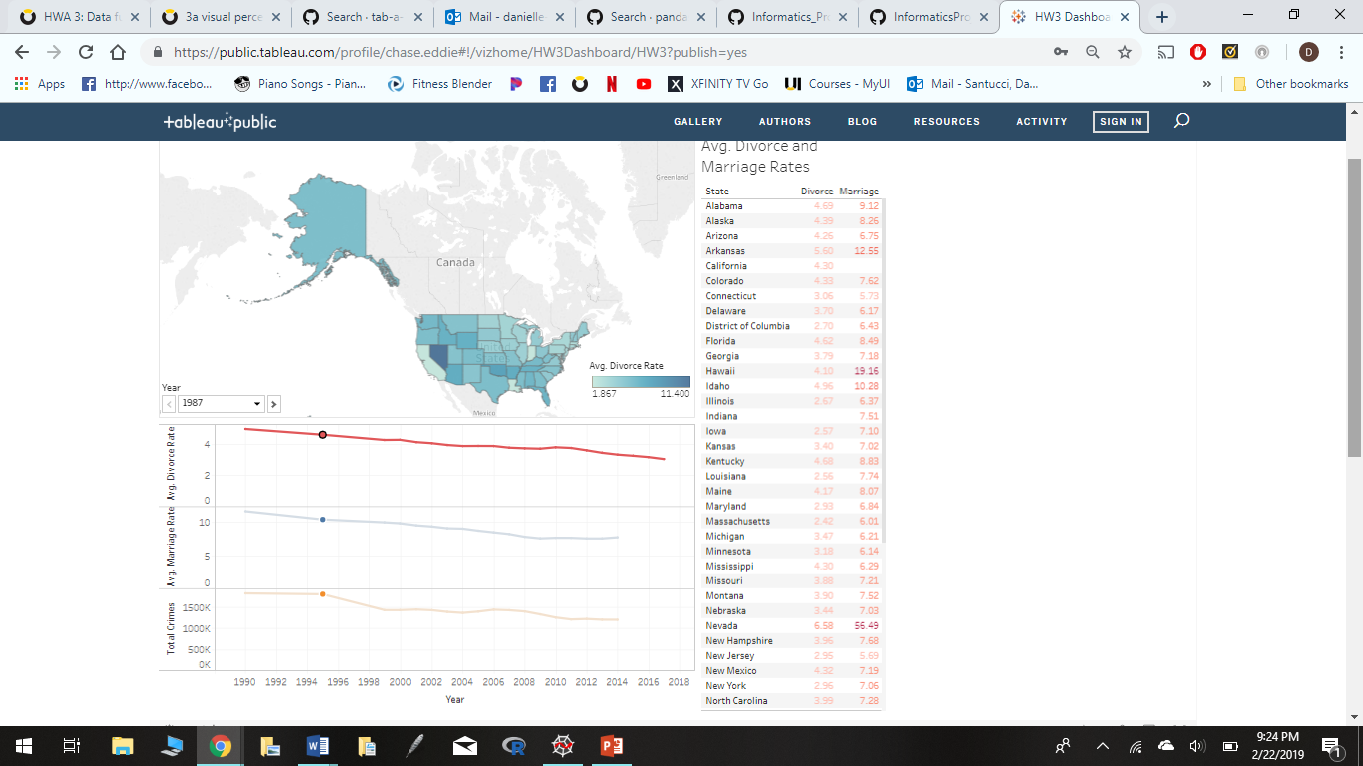 Three sheets are included in our dashboard: a map, text table, and line graph.

Each visualization includes features from all three datasets. For example, if you hover over the map you can see the average divorce rate, average marriage rate, and average united states total of 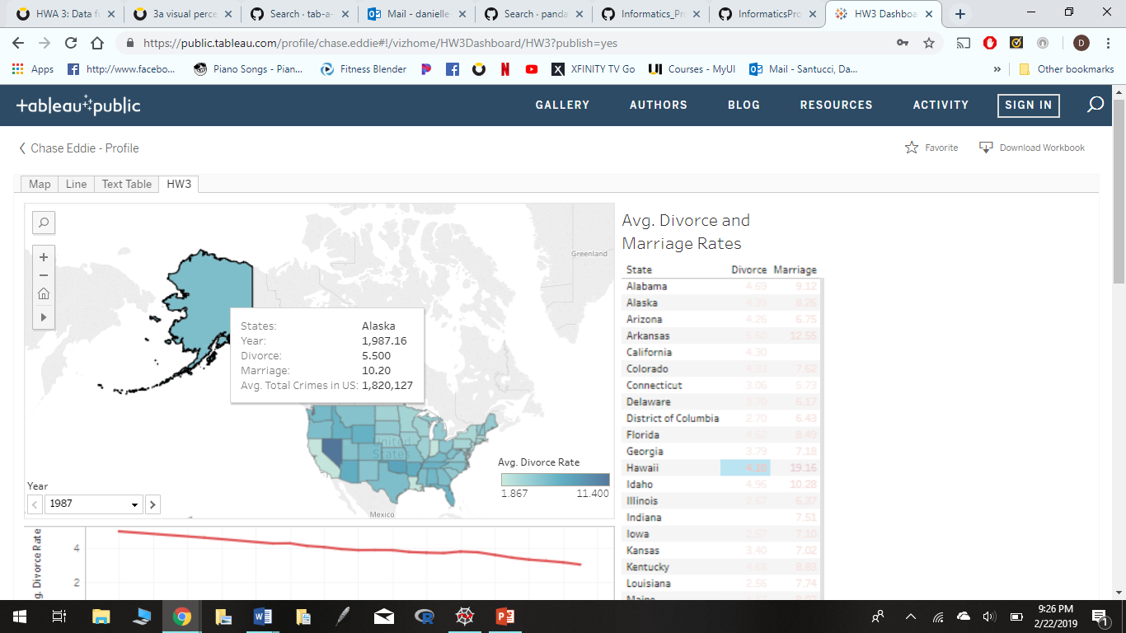crime rates. This is also per state and each of the states are colored in blue based on the intensity of the rate. This graph is beneficial for visual learners and can be easier read by physically having the state shape and map available. This idea is also implemented into the other tables. If you hover over the line 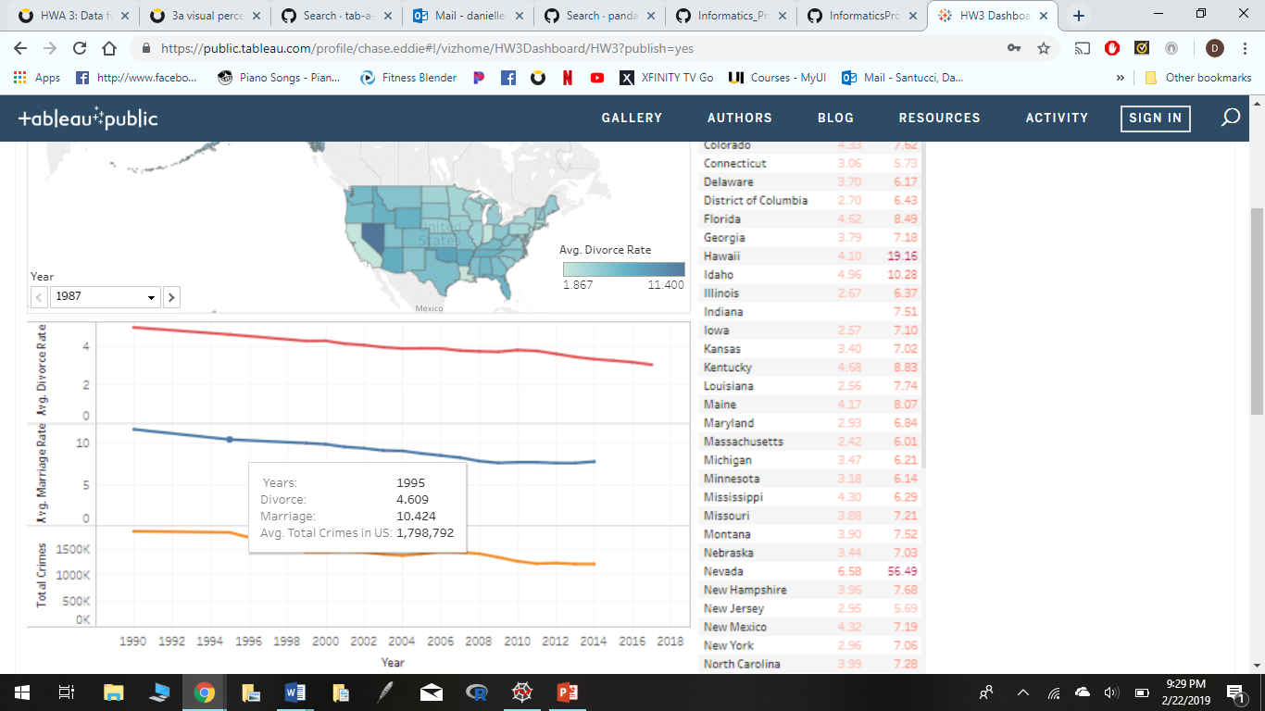graph you can see the above listed as well. However, this graph includes years instead of the states.

The third visualization lastly, also includes these features, as well as, using states into consideration, similarly with the map graph. Color intensity is also shown here, the dark red meaning: larger value and lighter meaning: lower.

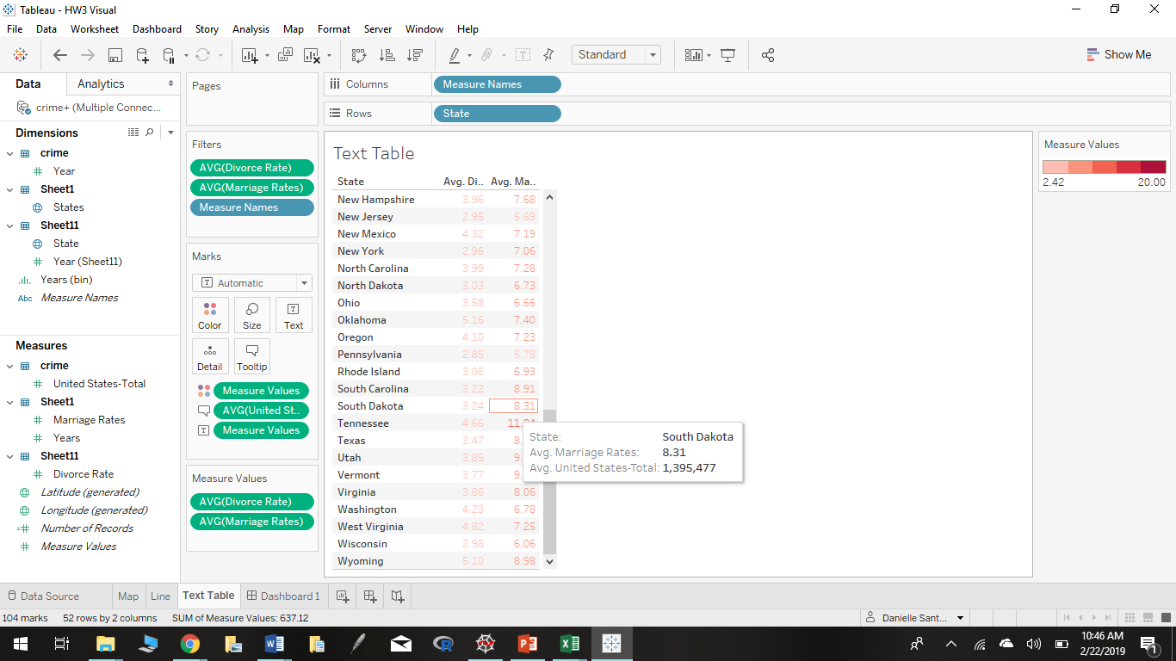

URL for Visual: https://public.tableau.com/profile/chase.eddie#!/vizhome/HW3Dashboard/HW3?publish=yes